**Securing RESTful Web Services with Spring Security**

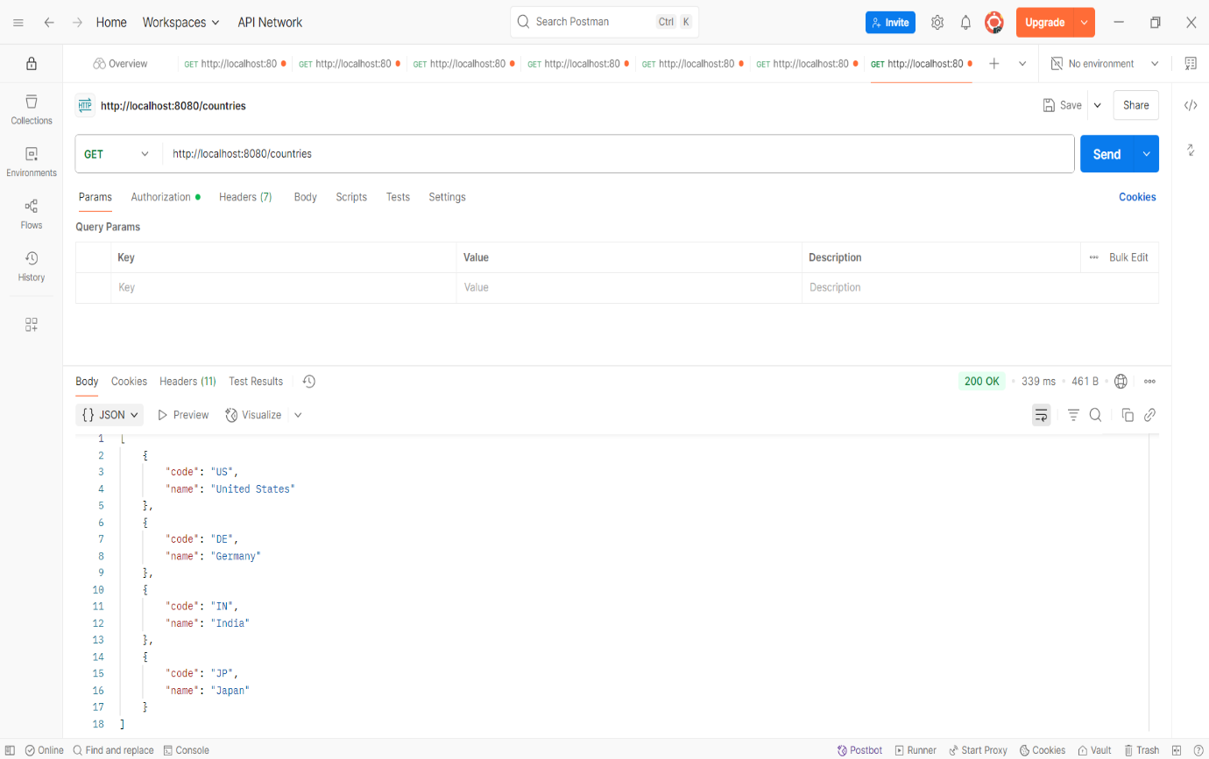

**Create authentication service that returns JWT**

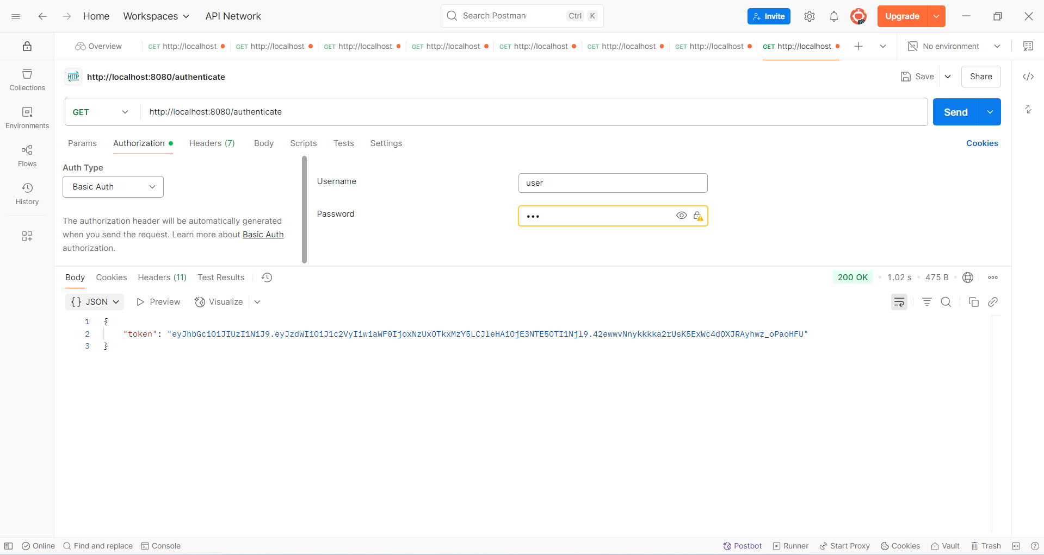

Create authentication controller and configure it in SecurityConfig

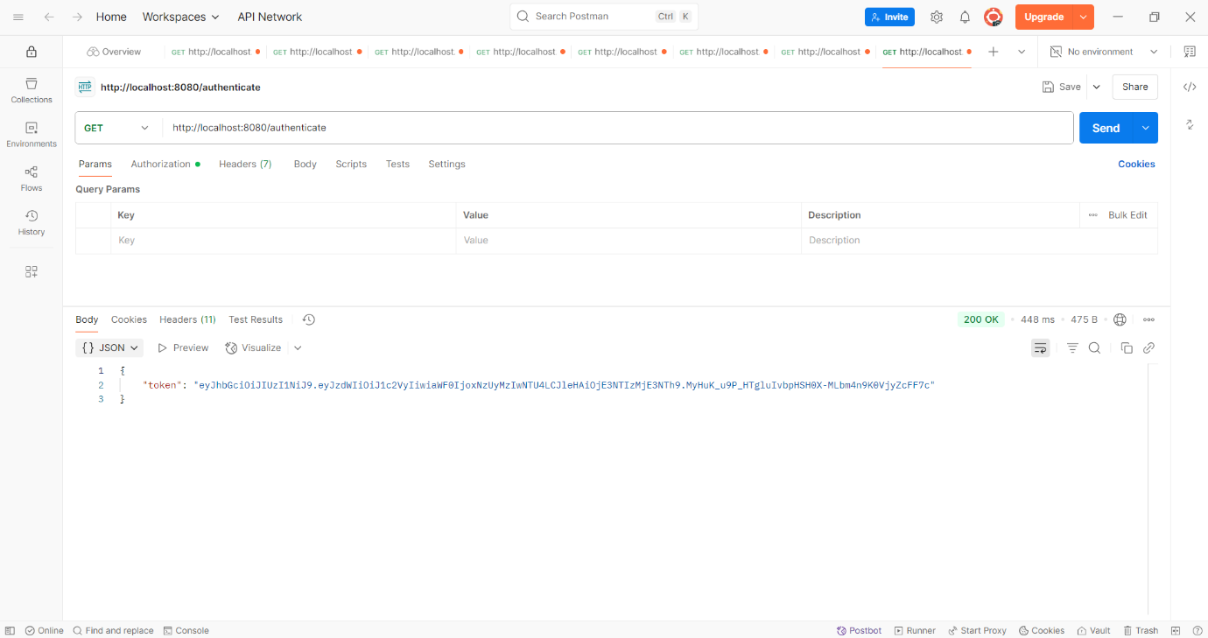

**Read Authorization header and decode the username and password**

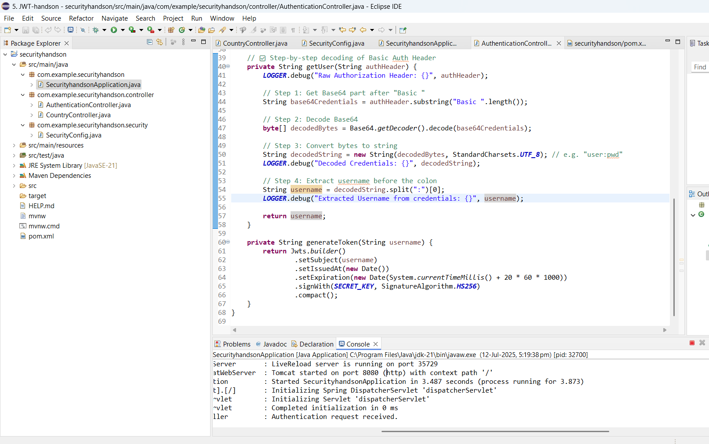

**Authorize based on JWT**

